CW04 | PHP Forms Lab
  - FINAL IMPLEMENTATION & TEST REPORT
CSC 6370 — Web Programming | November 1, 2026
Student: Monica Sai Chalasani | CODD username: mchalasani1
Project: https://codd.cs.gsu.edu/~mchalasani1/cw04/

1. Aim and project setup
This coursework demonstrates how PHP processes POST requests from HTML forms, handles multi-select values, checks four named inputs, escapes text sent back to the browser, and stores accepted fictional submissions in a CSV file. All sample data is invented. The form is a classroom simulation only, not a payment or academic-record service.
The website was uploaded to the assigned CODD web folder. The supplied November 1 screenshots establish that the home page loaded, PHP executed, and the checkbox selector displayed both selected choices. A revised copy with the instructor-style formtest files and a four-field student ID form is included in the final code folder. The revised files were tested locally, but a new upload to CODD has not been independently confirmed.

2. Core exercises and implementation

Exercise 1 — Execute PHP and debug multi-select
hello.php prints “Hello world!”, a random integer using rand(1, 10), and the literal text rand(1, 10). The updated formtest.html uses method="post", action="formtest.php", and a multiple select named features[]. The choices are Chat, Email and Shell. PHP reads $_POST["features"] as an array, checks its type and allowed values, and displays the selected choices with htmlspecialchars(). Missing optional selections get a friendly message; a scalar or unknown value is rejected. The pre-existing features.php checkbox demonstration remains as additional visual evidence.

Exercises 2 and 3 — Form and output
buy_grade.php contains four named fields: student_name, student_email, student_id, and requested_grade. Every field has a label. The form uses POST to process_grade.php, which reads and normalizes the submitted values. Valid values are displayed back to the student using HTML escaping so that submitted markup appears as text rather than executing.

Exercise 4 — Save one record per valid submission
The handler opens data/submissions.csv after the validation checks succeed. It takes an exclusive lock, writes a CSV header only when the file is empty, and appends one CSV row containing the UTC timestamp, fictional name, email, student ID, and requested grade. PHP’s fputcsv() handles CSV quoting. Direct browser access to the data directory is denied by its Apache .htaccess rule.

Exercise 5 — Validate inputs before writing
The server rejects blank names, invalid email format, an ID outside the 4–16-character letters/numbers/hyphen pattern, and any grade outside A/B/C/D/F. A rejected request returns readable error messages without appending CSV data. The form also has basic browser-side requirements, but the PHP checks are the authoritative safeguard.

3. Debugging explanation — The Case of the Missing Features
Prediction: with no selected options, the optional features key can be absent; with one option the submitted value should contain one element; with Chat + Email + Shell the handler should receive three values. A multi-select control must use an array-style name, such as features[], so PHP can preserve multiple values as an array. Processing only a single string would lose the remaining choices or produce an incorrect result. The updated handler checks that the received value is an array and never prints passwords or raw request dumps.
Locally verified repair behavior: zero options displays a clear empty message; Chat displays once; Chat + Email + Shell displays all three; malformed scalar or unknown feature input produces an error without a PHP warning. The actual instructor archive’s pre-repair Network payload was not supplied, so no original before-repair observation is asserted here.

4. CODD browser evidence — November 1, 2026
The four screenshots below are the actual browser images supplied for the earlier deployed version. They confirm the displayed pages, not the revised files or CSV permissions.
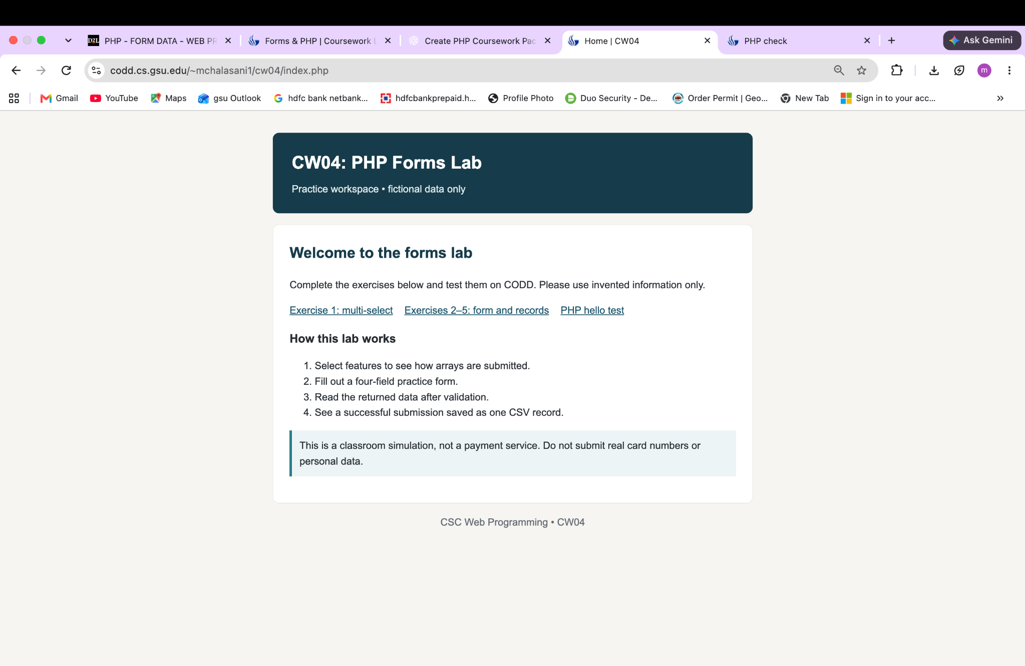
Figure 1. CODD index.php loads the lab landing page.
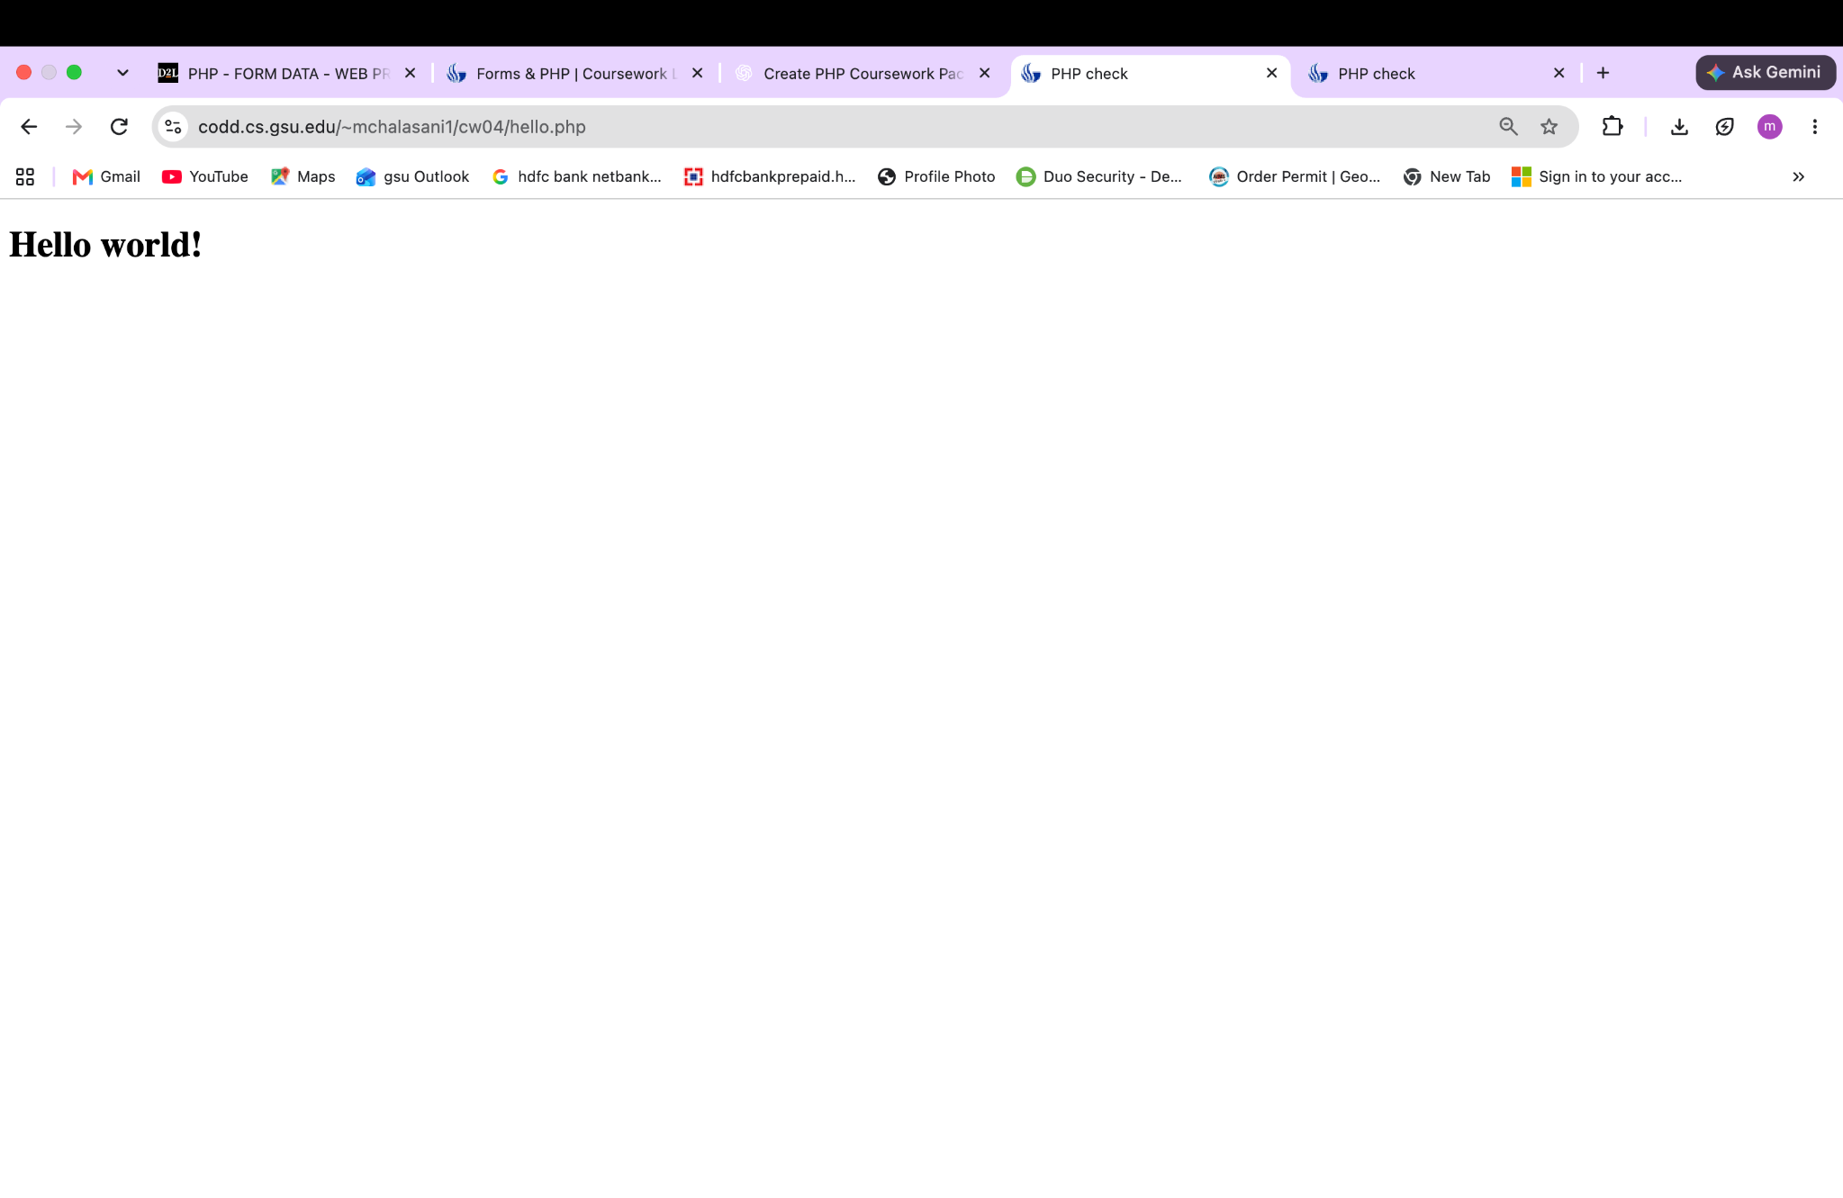
Figure 2. CODD hello.php displays “Hello world!”. This earlier screenshot does not show the updated random-number paragraphs.

4. CODD browser evidence (continued)
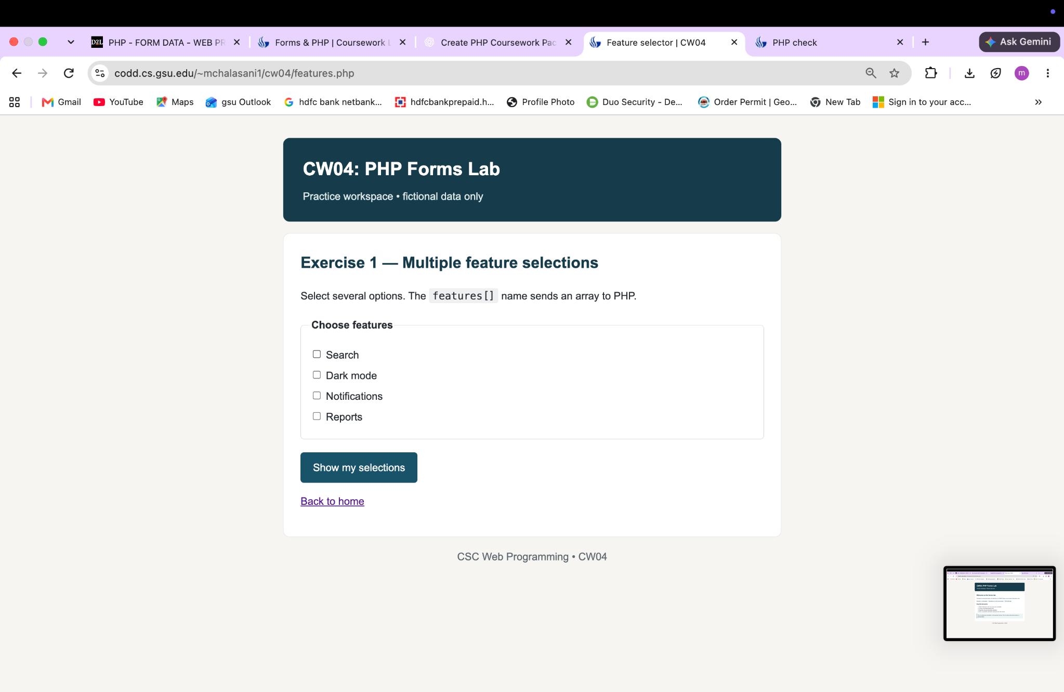
Figure 3. CODD features.php renders Search, Dark mode, Notifications and Reports.
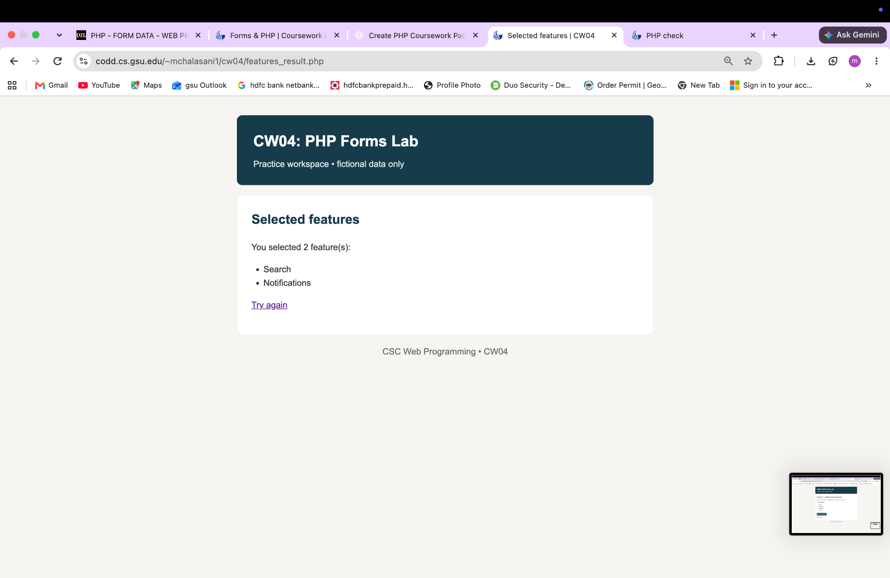
Figure 4. CODD features_result.php displays two choices: Search and Notifications.

5. Reproducible local verification
Environment: PHP 8.4 CLI built-in web server on localhost, automated with a Python script. The test script works on a temporary copy, leaving the submitted CSV file empty. All 21 checks passed in the local run; these checks are not a substitute for rerunning form submissions on CODD after uploading the new version.
Test case | Observed local result
PHP warm-up / home | Hello world, random/literal paragraphs and working links
T01 no selection | Clear “No optional features were selected” response
T01 Chat only | One selected item displayed
T01 Chat + Email + Shell | Three selected items displayed
T02 invalid feature requests | Scalar and unknown choices rejected without a warning
Unsafe-looking HTML input | HTML tags escaped in responses
Valid four-field POST | Confirmation; CSV header + one data record
Missing name / invalid email | Both rejected; CSV row count unchanged
Invalid ID / invalid grade | Both rejected; CSV row count unchanged
Second/third valid submissions | One CSV record appended per accepted POST
Direct GET to processor | Form-first instruction; no record saved
Final CSV line count | 4 rows = 1 header + 3 accepted requests in temp copy
Extra safe preview | HTML escaped without saving; empty input rejected
Extra record audit | Counts 3 saved fictional submissions without exposing records
Extra session counter | PHP server-side visitor counter displayed
POST payload logging | Local formtest requests record actual encoded data; not CODD DevTools

Sample fictional form values: Demo Student; demo@example.test; DEMO1234; grade B. Rejected cases included a blank name, “not-an-email”, ID “A!”, and grade “Z”. The submitted folder contains tests/run_smoke_tests.py and tests/LOCAL_TEST_RESULTS.json so the results can be reproduced.

6. Three additional implementation checks
The revised code includes three additional functional demonstrations beyond the core exercises. Their exact titles have NOT been matched to the instructor’s five official choices, which were not available to inspect. The demos are fully described, but this report does not claim official graduate-track mission credit without that comparison.

Extension A — Safe preview without saving
mission_preview.php accepts 1–300 fictional characters and returns an HTML-escaped preview without writing data. Local evidence: script-like input was printed as text; an empty preview was rejected.

Extension B — Read-only record audit
mission_records.php opens the CSV with a shared lock, counts accepted records and reports the most recent UTC timestamp without showing student details. Local evidence: the record audit showed 3 after 3 accepted submissions in an isolated test.

Extension C — Server-side session counter
mission_session.php uses session_start() to track a visit count using PHP sessions and includes a reset button. Local evidence: the PHP page rendered a server-side session count.

7. Reflection
I learned that an HTML name attribute becomes a key in the PHP request array. I also learned that selecting several options is different from submitting a single string: the server has to expect and handle an array. I kept the output simple and used labels so a person can understand what each field asks for. When I reviewed the tests, I saw why checking inputs on the server matters even if the browser marks fields as required. I also learned that saving a record safely requires valid data, a writable server location, and an orderly append operation.
One limitation is that the final revised files have only been integration-tested locally. A fresh CODD write test and the instructor’s original ZIP baseline/Network observations would strengthen the evidence. The exact graduate mission choices must also be compared with the official course page before treating those as completed rubric items.

8. Final files and submission notes
Code folder: hello.php, formtest.html, formtest.php, features.php, features_result.php, buy_grade.php, process_grade.php, index.php, config.php, assets/style.css, mission_preview.php, mission_records.php, mission_session.php, data/.htaccess, data/submissions.csv, tests/run_smoke_tests.py, tests/LOCAL_TEST_RESULTS.json, tests/POST_CAPTURE_LOCAL.json, DEBUGGING_CASE_FILE.md, README.md and the upload script. Report: CW04_Monica_Submission_Report.docx.
Submit the code folder together with this Word document, as directed in iCollege. The new version should be uploaded and rechecked using the actual CODD URL before it is described as fully deployed. Deadline from instructor page: November 1, 2026, 11:59 PM.

9. Updated local HTTP response evidence
The following images were rendered from HTML responses returned by the revised PHP code running on a local PHP HTTP server. These are local evidence, not new screenshots from CODD. The earlier CODD screenshots in Section 4 document a separate prior deployed version.
Actual local POST payload for the three-choice test: fictional_name=Demo+Student&features%5B%5D=Chat&features%5B%5D=Email&features%5B%5D=Shell. In PHP this corresponds to $_POST["features"] = ["Chat", "Email", "Shell"]. Client-side request records are saved in tests/POST_CAPTURE_LOCAL.json. This is not a replacement for the professor’s starter-file pre-repair DevTools evidence.


Figure 5. Local PHP warm-up: Hello world, random integer, literal rand() text.
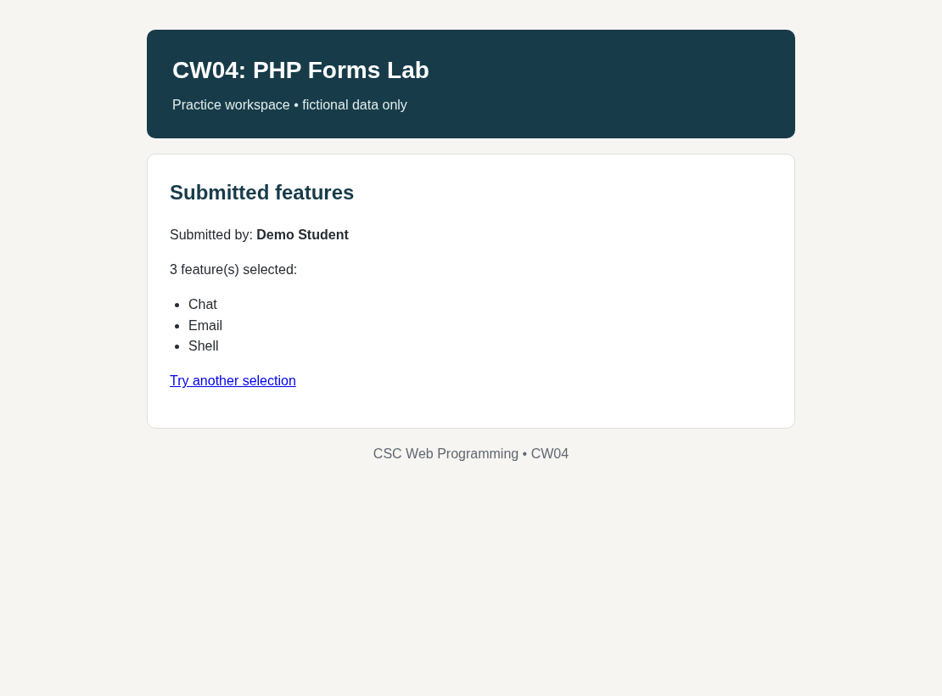
Figure 6. Local fixed multi-select: Chat, Email and Shell all preserved.

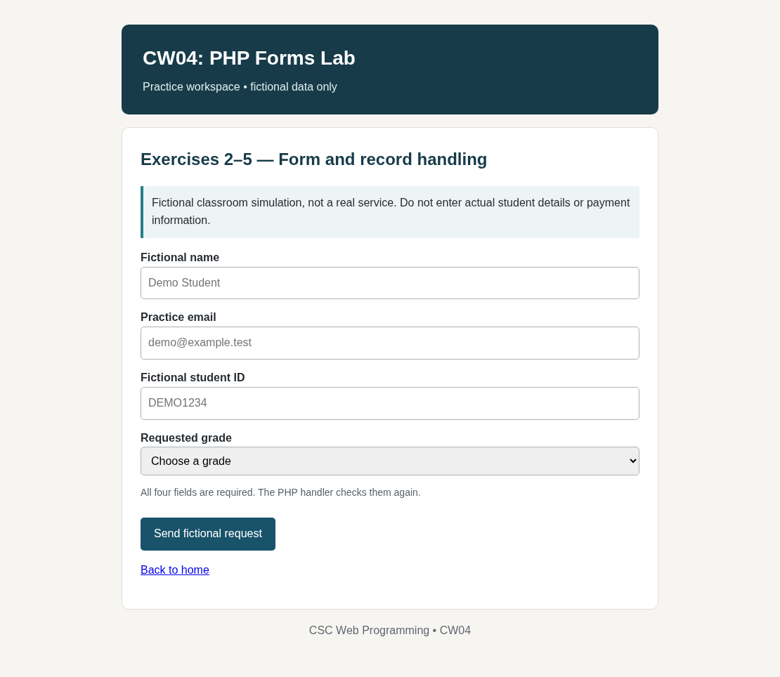
Figure 7. Local four-field fictional form: labels and allowed values.
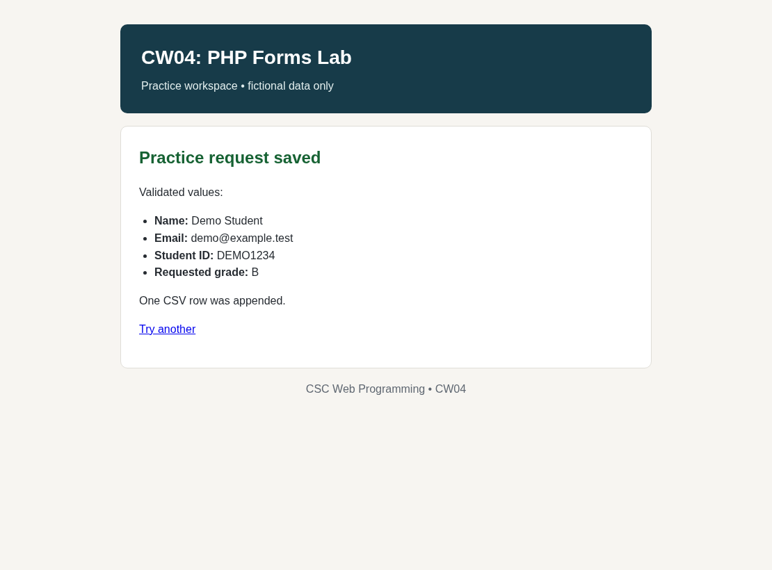
Figure 8. Local accepted POST: escaped response plus one CSV row.

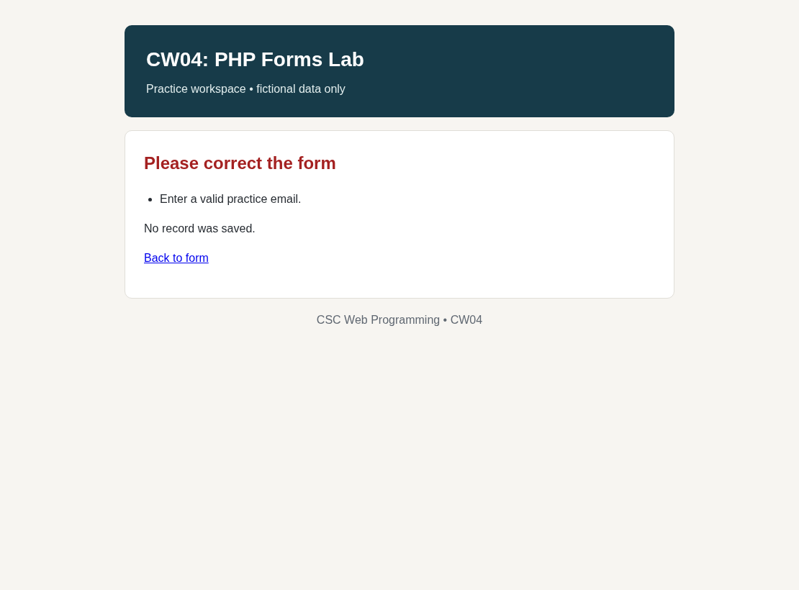
Figure 9. Local invalid email: readable error and no new CSV row.
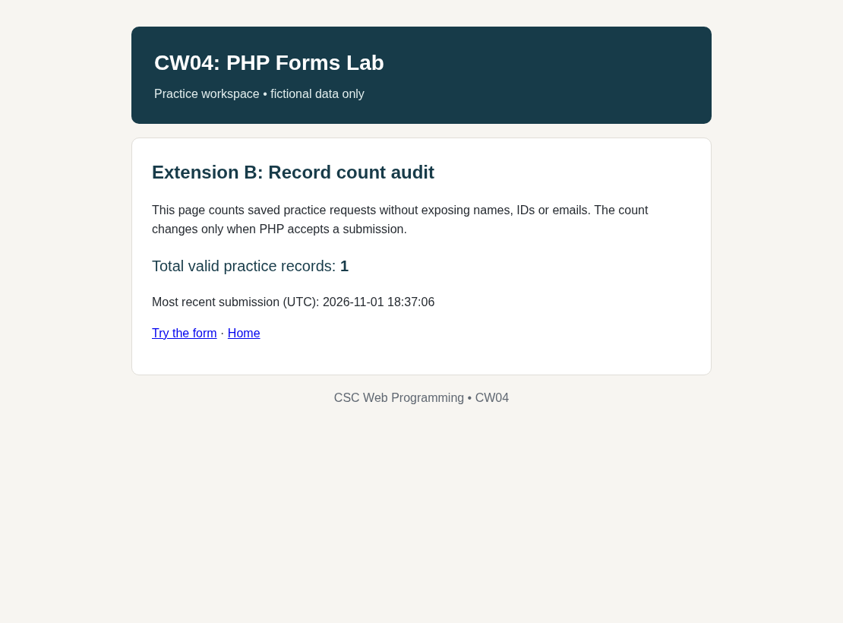
Figure 10. Local CSV audit: counts accepted records without exposing user fields.

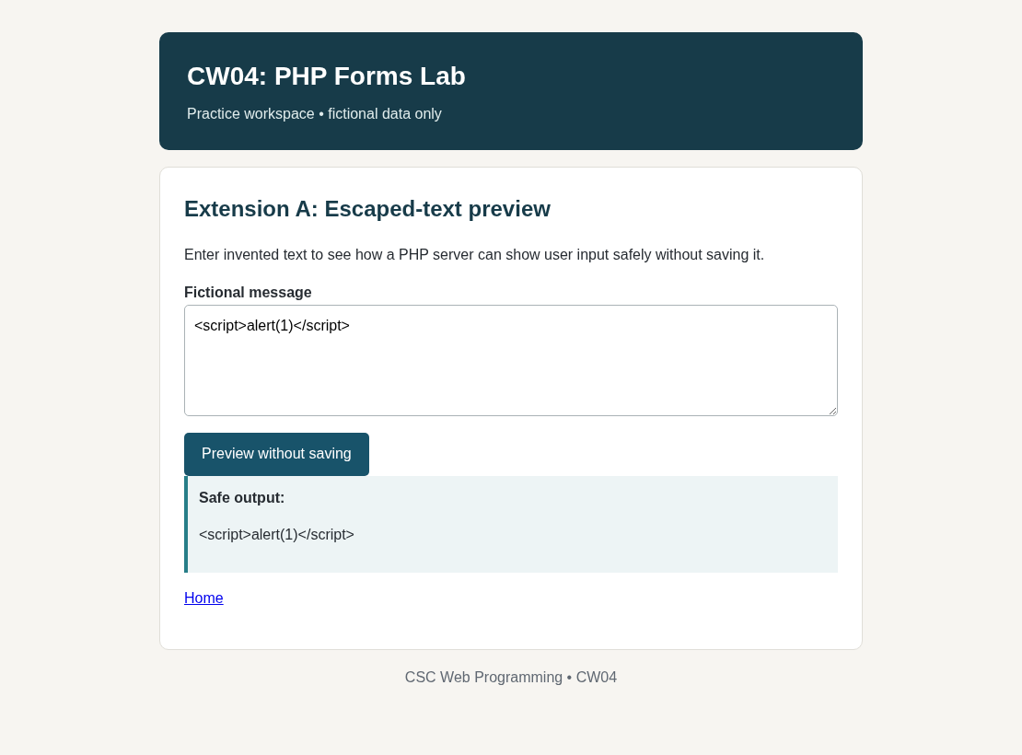
Figure 11. Local escaped-message preview: markup printed, not executed.
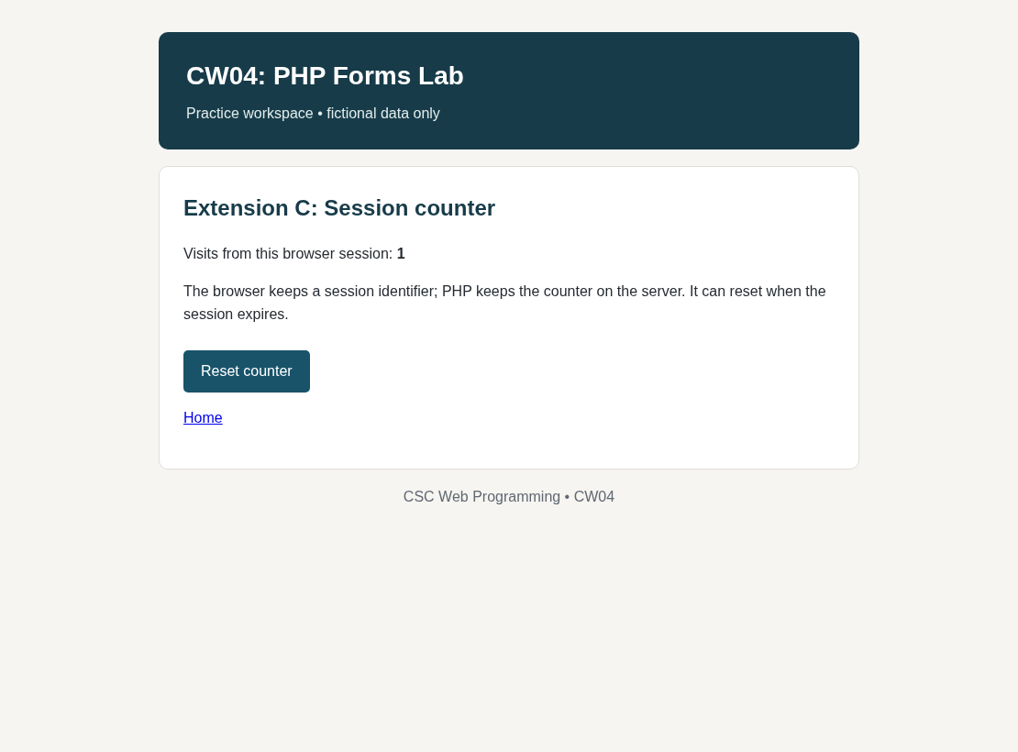
Figure 12. Local PHP session counter: separate optional demonstration.

10. Final test status and submission check
Locally completed: all PHP files pass php -l syntax validation; all 21 automated HTTP and CSV checks pass in an isolated local test directory; browser-rendered response images and original CODD screenshots are included; core exercise code and three optional demonstrations are in the ZIP. The entire local test run uses fictional sample values.

Known limits requiring student-account verification
- CODD deployment: the user’s four screenshots confirm the earlier version. The new ZIP has not been uploaded or tested on the user’s CODD account by this assistant.
- CODD file storage: the instructor’s server may require special write permissions. A real valid POST and an invalid POST must be checked there for CSV row-count behavior.
- Original instructor starter: the formtest.zip baseline file and its original before-repair Network results were not supplied. An honest independent replacement and a prediction/analysis file are provided, not a fabricated original baseline.
- Graduate track: the instructor requires 3 missions from the official five. The three extension pages in this ZIP are working examples, but the exact official mission names and requirements could not be confirmed.
- Final iCollege submission: the assistant has not submitted anything to the student’s iCollege Dropbox; the student must upload the files before the deadline.

Reflection
In this lab I traced how form controls are encoded into an HTTP POST and read through PHP. The feature selector taught me to distinguish a scalar from an array and to avoid assuming optional keys exist. I also learned that escaping generated HTML and validating all inputs on the server serve different purposes. For persistence, I used CSV writing with a file lock and checked that an invalid request could not add a record. The additional pages helped me practice safe previews, read-only audits and PHP sessions. My next verification step is to compare the code with the original starter files and test the updated ZIP on CODD.
Documentation: PHP Manual — https://www.php.net/manual/en/language.variables.external.php ; PHP fputcsv — https://www.php.net/manual/en/function.fputcsv.php ; MDN select — https://developer.mozilla.org/en-US/docs/Web/HTML/Reference/Elements/select

